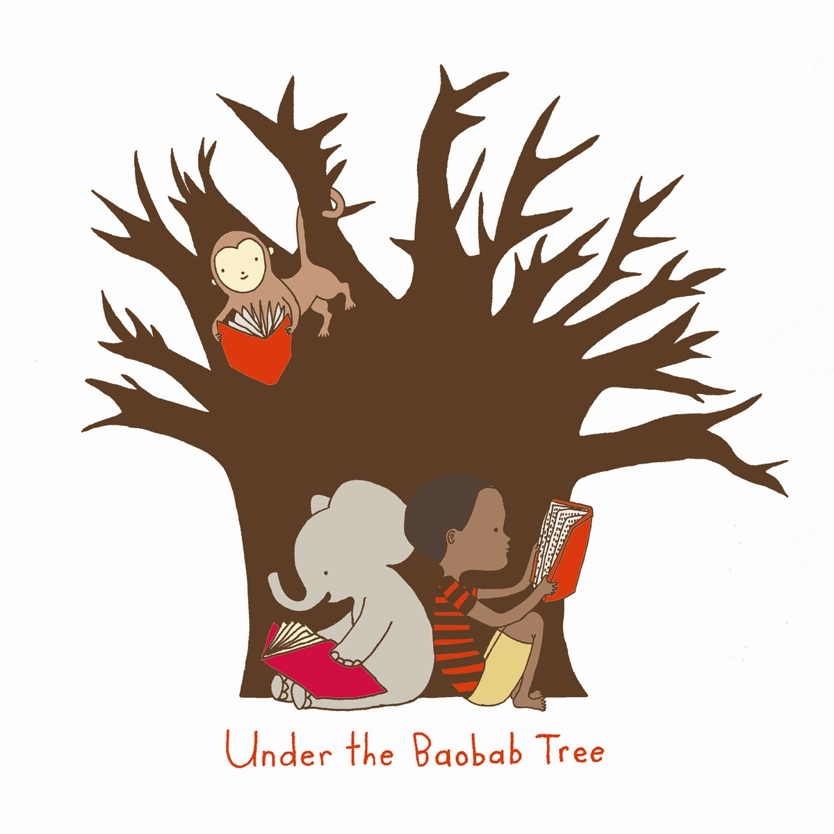

“Concern for man and his fate must always form his chief interest of all technical endeavors. Never forget this in the midst of your diagrams and equations.”

–Albert Einstein
Under The Baobab Tree (UTBT)-
Volunteer Program Application Form

Name ________________________________________________________________________________Date_________________________________
Street Address_____________________________________________________City_______________________State_______Zip____________
Phone_____________________________________________ Email__________________________________________________________________
University (If applicable)__________________________________________________Year _______Birth Date______________________

- What is your preferred program start date? (Circle one)
June 27 July 18 August 8 August 29 September 19 Other (please note) ________________

2. Are you a U.S. Citizen or permanent resident? (Circle one) Yes No
3. If no, what is your immigration status?_______________________________________________________________________________
4. How many weeks do you intend to stay in Malawi?_________________________________________________________________
5. How did you hear about us?___________________________________________________________________________________________
6. Are you a member or volunteer of any student/charitable organizations?_ __________________________________________________________________________________________________________________________________________________________________________________________________________________________________________________________________________________________________________________________________________________________________________________________
7. Have you ever worked or volunteered internationally? In which countries? ________________________________________________________________________________________________________________________________________________________________________________________________________________________________________________________________________________________________________________________________________________________________________________________________________________________________________________________________________________________________________________________
8. Please describe your interest in UTBT’s Volunteer Program: ____________________________________________________________________________________________________________________________________________________________________________________________________________________________________________________________________________________________________________________________________________________________________________________________________________________________________________________________________________________________________________________________________________________________________________________________________________________________________________________________________________________________________________________________________________________________________________________

Emergency Contact Information:

Name____________________________________________________________________Relationship To You____________________________

Email________________________________________________________Phone_______________________________________________________

Skills & Interests Section

Volunteer placements will be based on three factors: (1) the volunteer’s background skills, education and practical experience; (2) the volunteer’s interests; and (3) the needs of our community. To ensure maximum efficacy of your time spent with us in Namaso Bay, Malawi, please complete this questionnaire thoroughly.
Please select the type of volunteer placement that interests you most by listing your top three choices in order:

- Cottage Industry Microfinance/Business Development
- Sustainable agricultural development
- “Green” architectural design
- Visual arts/design to educate
- Community Center Programming-Bring the village together
- Documentary Film making
- Photographic Journalism
- Media Advocacy
- Working with women’s groups
- Home-based Care/mid-wifery
- Health Care Technologies
- Vocational Training (what is your skill?)
- Assisting people living with HIV/AIDS
- Capacity Building
- Culturally Sensitive Education -Curriculum Enhancement
- Other (please describe project ideas or specific interests)

1.

2.

3.

Please explain why you chose the above three interests:
Please describe an experience in which you employed skills that could be utilized within the above 3 chosen interest topics:

Please list any experiences, studies, or certifications that make you specifically qualified for the above interest topics:

In what size groups are you comfortable working? (Circle all that apply)

Children (0 to 16 years old): 1-4 5-10 Over 10 Adults: 1-4 5-10 Over 10

Please rate your general ability to work unsupervised on a scale of 1 to 10:
1 = You need firm instruction and nearly constant supervision
10 = You are a self-starter, can assess most situations, suggest solutions and implement them

Are you willing to work in any area you may be needed, regardless of your interests? Y/N

Please assess your skill based on the following numerical scale:

1 – No knowledge 2 – Some knowledge 3 – Competent 4- Expert

- EDUCATION
Teaching sports 1 2 3 4
Teaching English 1 2 3 4
Teaching other subjects 1 2 3 4

Please specify sports

Please specify subjects/certifications

- SKILL TRAINING
Business planning 1 2 3 4
Bookkeeping 1 2 3 4
Accounting 1 2 3 4
Computers 1 2 3 4
Graphic/web design 1 2 3 4

Other skills/certifications

- ARTS & CRAFTS
Dance 1 2 3 4
Music 1 2 3 4
Theatre Arts 1 2 3 4
Visual arts 1 2 3 4
Film 1 2 3 4
Photography 1 2 3 4
Other (sewing, pottery, knitting) 1 2 3 4

Other skills/certifications

- COMMUNITY BASED
Research (cultural, medical, and/or educational) 1 2 3 4
Conservation and/or environmental education 1 2 3 4
Nursery work—caring for small children 1 2 3 4
Social work, e.g., recording patients’ histories, 1 2 3 4
distributing medicines and/or birth control devices

Other skills/certifications

- HEALTH
Nutrition 1 2 3 4
Hygiene training 1 2 3 4
Health education 1 2 3 4
Sex education 1 2 3 4
Innovative Public Health Technologies 1 2 3 4

Other skills/certifications

- MEDICAL
Please describe any formal medical training and/or work experience:

- YOUR SKILLS
Please indicate which of the skills listed above you would most like to use and share while in Namaso Bay.

1.

2.

3.

Please explain your preferences:

What is your primary motivation for participating in UTBT’s volunteer program?

How do you personally hope to benefit from this experience?
Is there anything else we should know about you that would help us design a program curtailed to your interests and our community needs?

Is there anything else that has not been explored in the above form that could benefit a future volunteer project design?

Comments:

To participate in UTBT’s Volunteer Program, please complete and mail this Registration Form and 300 USD Deposit to Under The Baobab Tree, Inc.—1725 East Bayshore Road Suite 103, Redwood City, CA 94063. US Citizenship is not a criterion for participation. The above information will be used for administrative purposes only, provided that it is legal for you to travel in Malawi. Please note that space is limited and enrollment is determined by a competitive application process and is based on the needs of our community. If a candidate is not selected for any reason, his or her application fee will be returned in full. Under The Baobab Tree, Inc. is a 501©3 tax-exempt organization EIN- 26-2402825. For more information, please visit www.utbt.org.

