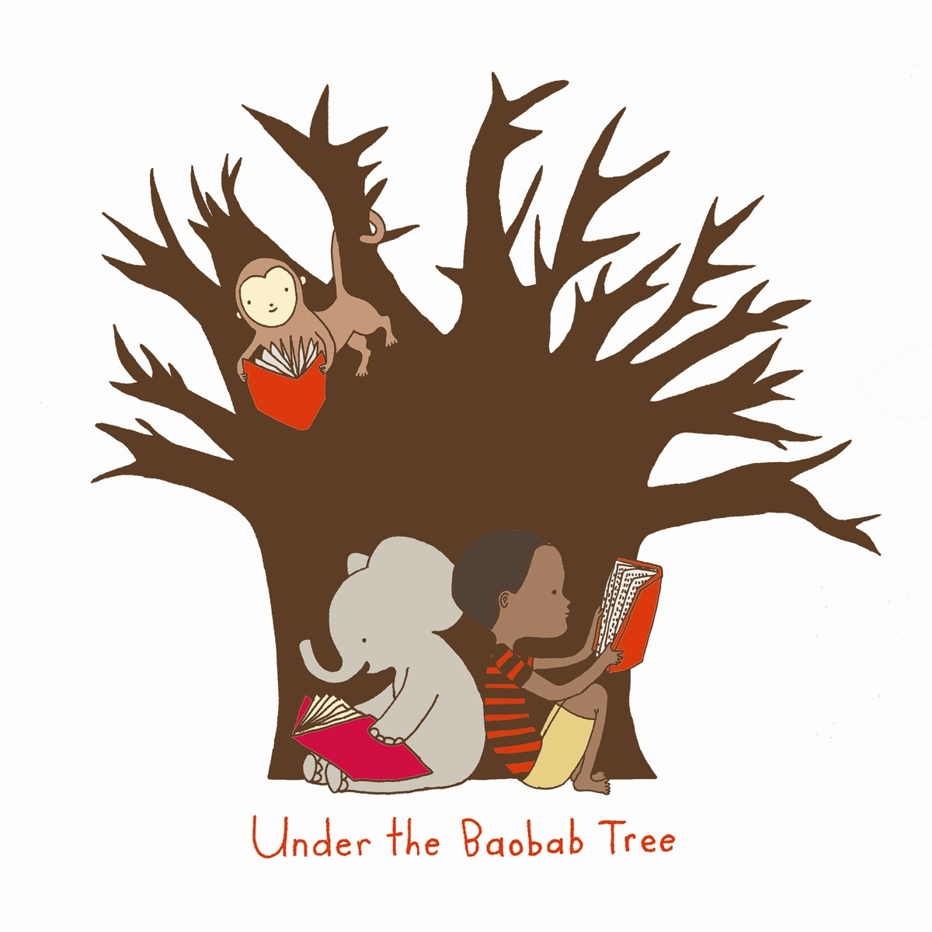

“Any intelligent fool can make things bigger and more complex. It takes a touch of genius and a lot of courage to move in the other direction.” -Albert Einstein

Under The Baobab Tree (UTBT)-
LAST Program Application

Name ________________________________________________________________________________Date_________________________________
Street Address_____________________________________________________City_______________________State_______Zip____________
Phone_____________________________________________ Email__________________________________________________________________
University (If applicable)__________________________________________________Year _______Birth Date______________________

- What is your preferred program start date? (Circle one)
June 28, 2009 June 26, 2010 Other (please note) ________________

2. Are you a U.S. Citizen or permanent resident? (Circle one) Yes No
3. If no, what is your immigration status?_______________________________________________________________________________
4. How many weeks do you intend to stay in Malawi?_________________________________________________________________
5. How did you hear about us?___________________________________________________________________________________________
6. Are you a member or volunteer of any student/charitable organizations?_ __________________________________________________________________________________________________________________________________________________________________________________________________________________________________________________________________________________________________________________________________________________________________________________________
7. Have you ever worked or volunteered internationally? In which countries? ________________________________________________________________________________________________________________________________________________________________________________________________________________________________________________________________________________________________________________________________________________________________________________________________________________________________________________________________________________________________________________________
8. Please describe your interest in UTBT’s LAST Volunteer Program: ____________________________________________________________________________________________________________________________________________________________________________________________________________________________________________________________________________________________________________________________________________________________________________________________________________________________________________________________________________________________________________________________________________________________________________________________________________________________________________________________________________________________________________________________________________________________________________________

Emergency Contact Information:

Name____________________________________________________________________Relationship To You____________________________

Email________________________________________________________Phone_______________________________________________________

Skills & Interests Section
The below list of “greening” topics will help us determine the pre-existing skill sets of our LAST team members and interest levels among topics.
Please select from the topics listed below those that interest you most. List your top three choices in order:

- Mapping an area for maximum results
- Working with the community to learn about resources available and local customs
- Creating a “green” plan
- Installing solar panels
- Installing water catchment/drip systems
- Installing Compost toilets/Community Compost
- Biogas
- Using waste to beautify
- Building interactive bio-intensive garden
- Building chicken coups
- Keeping it sustainable through community involvement and education.
- Incorporating these techniques within village life-spreading the “eco-message”

1.

2.

3.

Please explain why you chose the above three interests:

Please describe an experience in which you employed skills that could be utilized within the above 3 chosen interest topics:

Please list any experiences, studies, or certifications that make you specifically qualified for the above interest topics:

In what size groups are you comfortable working? (Circle all that apply)

Children (0 to 16 years old): 1-4 5-10 Over 10 Adults: 1-4 5-10 Over 10

Please rate your general ability to work unsupervised on a scale of 1 to 10:
1 = You need firm instruction and nearly constant supervision
10 = You are a self-starter, can assess most situations, suggest solutions and implement them

Please assess your skill based on the following numerical scale:

1 – No knowledge 2 – Some knowledge 3 – Competent 4- Expert

Mapping an area for maximum results ___________
Working with the community to learn about resources available and local customs ___________
Creating a “green” plan ___________
Installing solar panels ___________
Installing water catchment/drip systems ___________
Installing Compost toilets/Community Compost ___________
Biogas ___________
Using waste to beautify ___________
Building interactive bio-intensive garden ___________
Building chicken coops ___________
Keeping it sustainable through community involvement and education. ___________
Incorporating these techniques within village life-spreading the “eco-message” ___________

What is your primary motivation for participating in UTBT’s volunteer LAST program?

How do you personally hope to benefit from this experience?
Is there anything else we should know about you that would help us?

